**class** Student {

**public** Student() {

*num*++;

}; // 调用无参构造函数时num加1

**public** Student(String name, **int** score) // 调用有参构造函数时num加1

{

**this**.name = name;

**this**.score = score;

*num*++;

}

**public** **void** setname(String name) {

**this**.name = name;

}

**public** **void** setscore(**int** score) {

**this**.score = score;

}

**public** String getname() {

**return** **this**.name;

}

**public** **int** getscore() {

**return** **this**.score;

}

**private** String name; // 学生姓名

**private** **int** score; // 学生成绩

**static** **int** *num*=0;

}

**public** **class** Student2 {

**public** **static** **void** main(String[] args) {

Student stu1 = **new** Student();

stu1.setname("zhangsan");

stu1.setscore(88);

Student stu2 = **new** Student("lisi", 81);

Student stu3 = **new** Student();

Student stu4 = **new** Student();

Student stu5 = **new** Student();

System.***out***.println("num:"+Student.*num*);

}

}

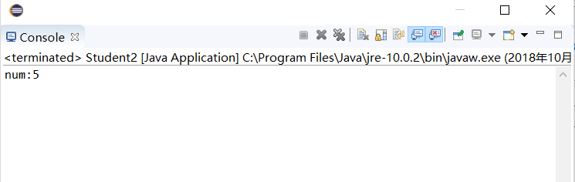

心得：使用static创建类变量，可用于记录对象的个数，用类名.对象名来访问。